Consultation on Ulverscroft Play Area Upgrade
The play area in Ulverscoft was built around 25 years ago, for children up to 7 years old. The main climbing frame is beginning to rot. The see-saw has rotted and been removed. The soft surface is worn and damaged and the springers for toddlers are not well used. The swings are more recent and will stay, but the Parish Council is aiming to replace the other equipment to make it a good play area again.
We’ve received some estimates, and it will cost around £30,000. MK Council, and the ward councillors will pay part of those costs, but the Parish will pay for most of it. We’ll be trying local companies to see if they can help too. At the same time, we’d like to know what you think of the proposals put forward. And then we’ll try to match up the money available with your preferences, and choose the best equipment. It will take time; it will probably be late this year before the new equipment is installed.
Please complete the Answer sheet with this leaflet, and return it as shown on the sheet, by the 23rd March. Thank you.

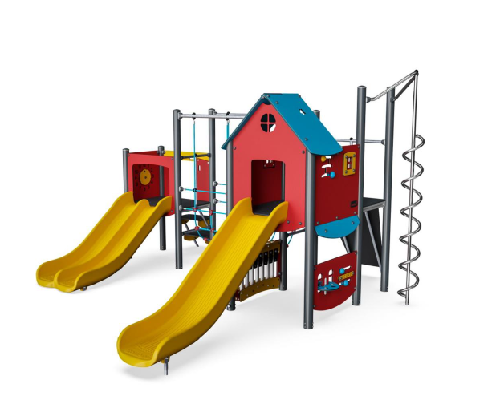
QUESTION 1. We have received a mix of quotes for assemblies of equipment, and for individual items on them. Which assemblies attract you? Please pick one or two. Why do you prefer them?
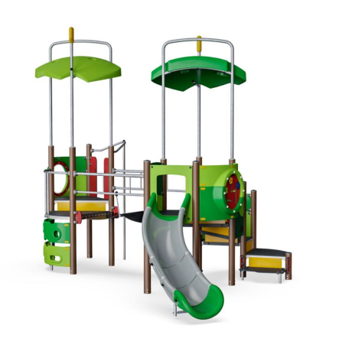
A
B

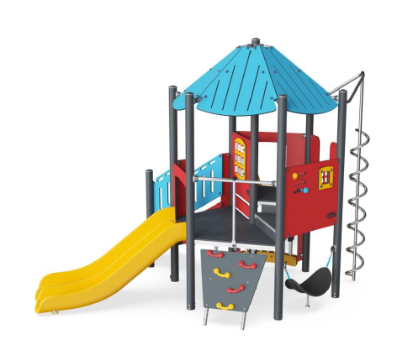
C

QUESTION 2: What would you most like to have on the climbing frame? Please pick up to five.
- Ladder 2. Platfom ladder 3 Firemans 4 Spiral
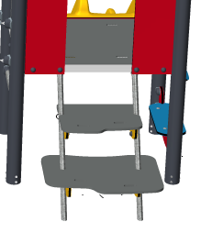
Pole Pole
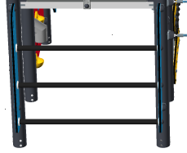

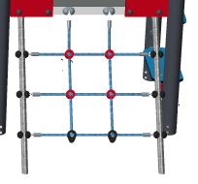
- Climbing net 6 Climbing wall 7 Single slide 8 Double slide
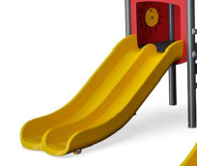
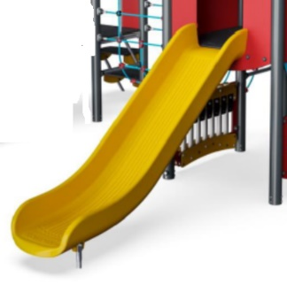
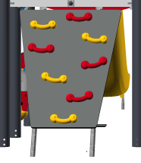

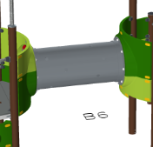
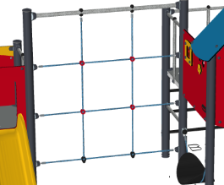
9 Tunnel bridge 10 Bridge 11 U-rope bridge 12 Rope Climber bridge
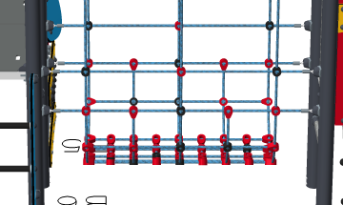
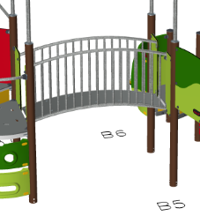

13 Membrane bridge 14 Xylophone 15 Pipes/tubes
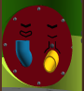
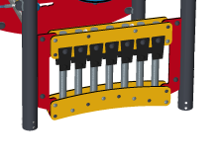
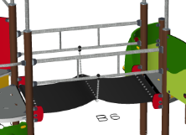

16 Flowers or balls in groves to move around 17 Calculator/counter panel

18 And there’s a tic tac toe game

Overall Equipment and Layout
At present the equipment consists of: It’s proposed to replace it with:
Swings The existing swings
Climbing Frame A new climbing frame
(seesaw was removed) A new seesaw
Springers A new roundabout
QUESTION 3: Are you happy with that mix? Any comments?

The space for the roundabout is somewhat restricted, but this is the best one we can find to fit in the space.
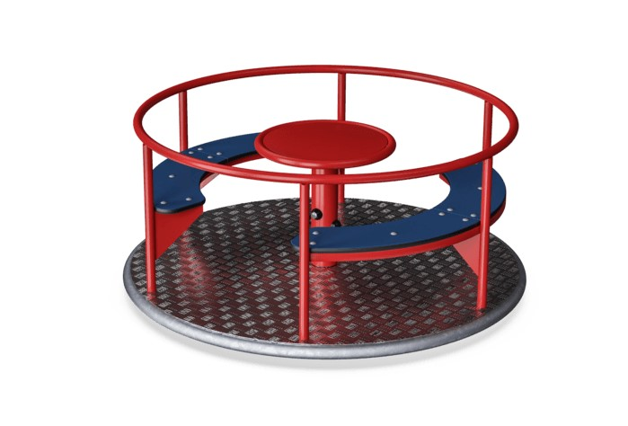

QUESTION 4: We have found two designs of a seesaw for the space. Which do you prefer?
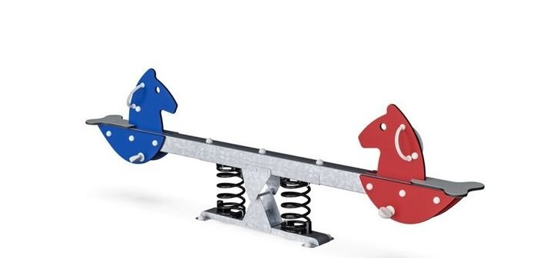
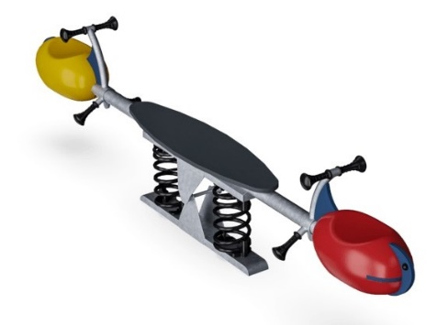
4A 4b

This is the layout that is most likely for the new equipment

Existing swings New seesaw new roundabout new climbing frame
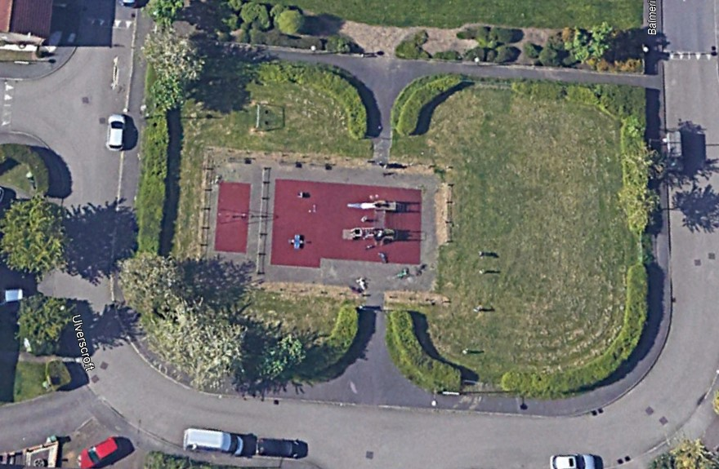
Chicksands
Ave

Monkston Green

Ulverscroft Balmerino Close

QUESTION 5: Do you have any comments on the layout?

Parkminster houses

Ulverscroft Play Area Consultation
ANSWER SHEET

Please mark your answers and then return the questionnaire by March 23rd 2021 to either:
Monkston School office or

Parish Clerk, Kents Hill & Monkston Parish Council
PO Box 6293, Milton Keynes MK10 1ZG

The play area is intended for children aged 0-7 years. If you have children in both the pre-school age group and the school age group, please fill in a form for each age group. Thank you.

FIRST, a little about you:
Are you a child or an adult? | Child Adult Boy Girl
If child how old are you?
If adult, what age are the children you are thinking of?

Which estate do you live on?

QUESTION 1 for children.
Which one or two play assemblies do you prefer? | A B C

What do you particularly like about them?

QUESTION 2 for children.
Which 5 items of equipment do you most want us to include?
1.
2.
3.
4.
5.

QUESTION 3 For everyone:
Are you happy with the proposed mix of equipment? (climbing frame, roundabout, swings, seesaw). Any comments?

QUESTION 4:
Which seesaw do you prefer? | A | B

QUESTION 5: Any comments on the site layout? Or any other comments?

Thank you!

